Background: It is widely recognised that grass-based systems offer a competitive advantage and will predominate in Ireland. However, grazing systems that have been developed to utilise large quantities of grazed grass have in the main been based on low-output per cow. In this scenario, high levels of profitability are possible through avid cost control and comparatively high stocking rates for grazing systems. There are now reasons to consider the development of grazing systems that are based on high-output per cow. These reasons include (i) concerns about increasing dairy cow numbers and environmental emissions, (ii) facilitating farm expansion post EU-milk quota removal for land limited and fragmented farms, (iii) lack of available skilled labour on farms to deal with expanding animal numbers. The rationale for this research is that a high output grass-based spring milk production system can be profitable when built on a foundation of good grassland management and meeting both milk and fertility targets and has a place in a sustainable Irish dairy industry.
For more details on the High Output Systems Research Herd visit
https://www.ucd.ie/agfood/about/lyonsresearchfarm/lyonsdairyherd/

Lyons Systems Research Herd Notes Week 11/04/2022
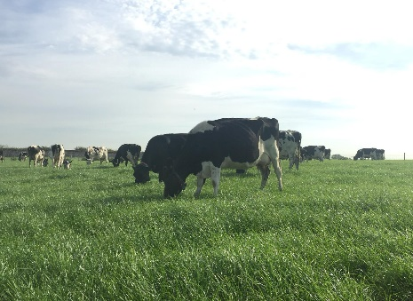
Farm Details:
Area available: 17.43 ha
Current Stocking Rate (MP): 3.27
Farm Cover: 597 kg DM/ha
Growth Rate: 17 kg DM/ha/day
Demand: 52kg DM/ha/day
Average Concentrate Supplement: 8 kg/head/day
Average DIM: 52 days
Cows Calved: 57/57 cows
Current Daily Feed Budget: Cows are being fed on average 8kg of a conventional 18% crude protein concentrate or a 14% crude protein concentrate (formulated with native ingredients) in the parlour. Concentrate intake is built up gradually over two weeks post-calving. The concentrate formulation is part of this year’s nutritional study. Cows are fed 8kg concentrates from calving to 60 DIM and are allocated 16 kg DM grass.
Spring Grazing Plan: The current AFC is 597 kg DM/ha (range 50 to 1560kg DM/ha). Average daily growth rate is 17 kg DM/ha this week. Between 4th April and 10th April, the average soil temperature at 100mm was 7.2 ºC and 10.9 mm rain fell (rain data from the nearby Met Eireann station, Casement Aerodrome). Growth has been slow over the past two weeks due to the colder weather with light snow showers even being recorded on farm. Paddock cleanouts have been good even with heavier covers coming into the end of the first round. Cows are achieving a post grazing height of 4 to 5 cm which has allowed for the extension of the first round into mid-April. The original planned start date of the second round of grazing was the first week of April. Due to the colder temperatures leading to poorer grass growth rates, the first round was extended to allow paddock covers to increase for the second round. Demand for grass is currently at 52kg DM/Ha meaning magic day will most likely be around the start of May this year. Average DM for the week was 22%. This will fall as we begin the second round on the back of lighter covers and fresh grass.

Calving: Calving started on 30th January, and as of 10th April, all the cows are calved. One calved in January, 46 in February, 9 in March and 1 in April. The average gestation of the calved cows is 279 days. To date, 29 heifer calves and 28 bull calves have been born.

Milk Production:
Average production from 2 ^{nd} April to 10th April was 36.85 kg/cow at 4.72 %fat, 3.56 % protein (3.01kg MS) and SCC was 202,000. Milk production from this time last year was 36.8 kg/cow at 4.25% fat, 3.41% protein (2.82 kg MS) and SCC was 48,000.
BCS:
Body condition scoring was carried out on the 5th of April. 4 cows (7%) scored 2.5, 53 cows (93%) were on target for breeding, between 2.75- 3.25. The average was 2.96 BCS.

